KIWI ELECTRONICS: USERS GUIDE

**Login Page:**

When first entering our website the user will see a greetings page.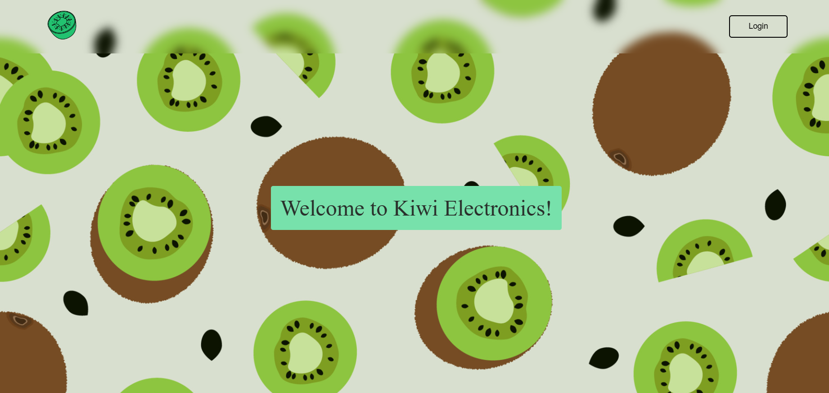

In the top right hand corner, there is a login button for new and returning users.

After pressing the button, the user is shown a log in pop up.

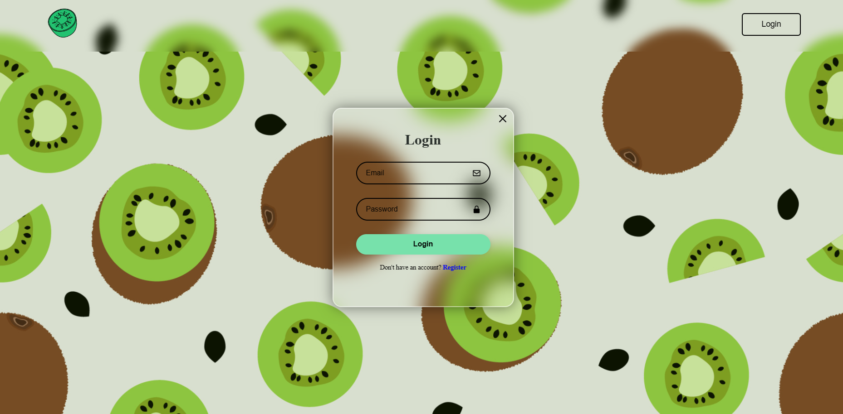

If the user is an returning user, they will enter their email and password that they used to register. Otherwise, they will press the register button.

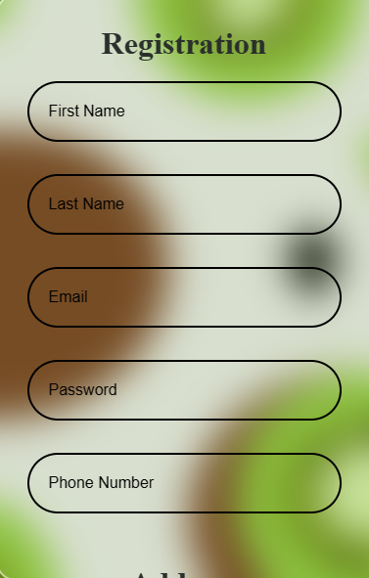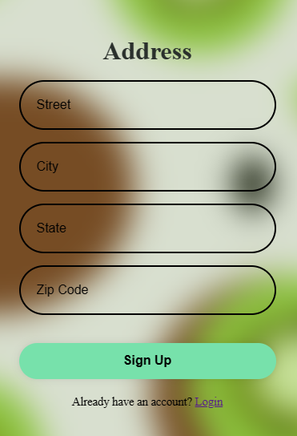

To register for a new account, the user will enter all the information prompted by the login pop up, and then press sign up.

After making a new account, the user will be directed back to the greetings page. The user will once again press the login button, and this time enter their information and press login.

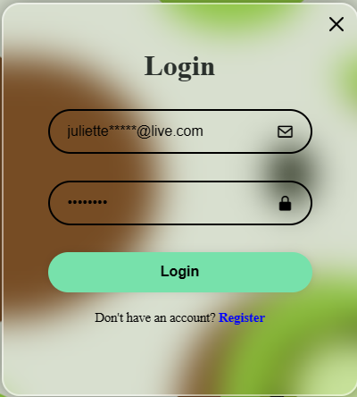

**Products Page:**

After logging in the user will be redirected to the products page, where they are able to view all of the products in our store.

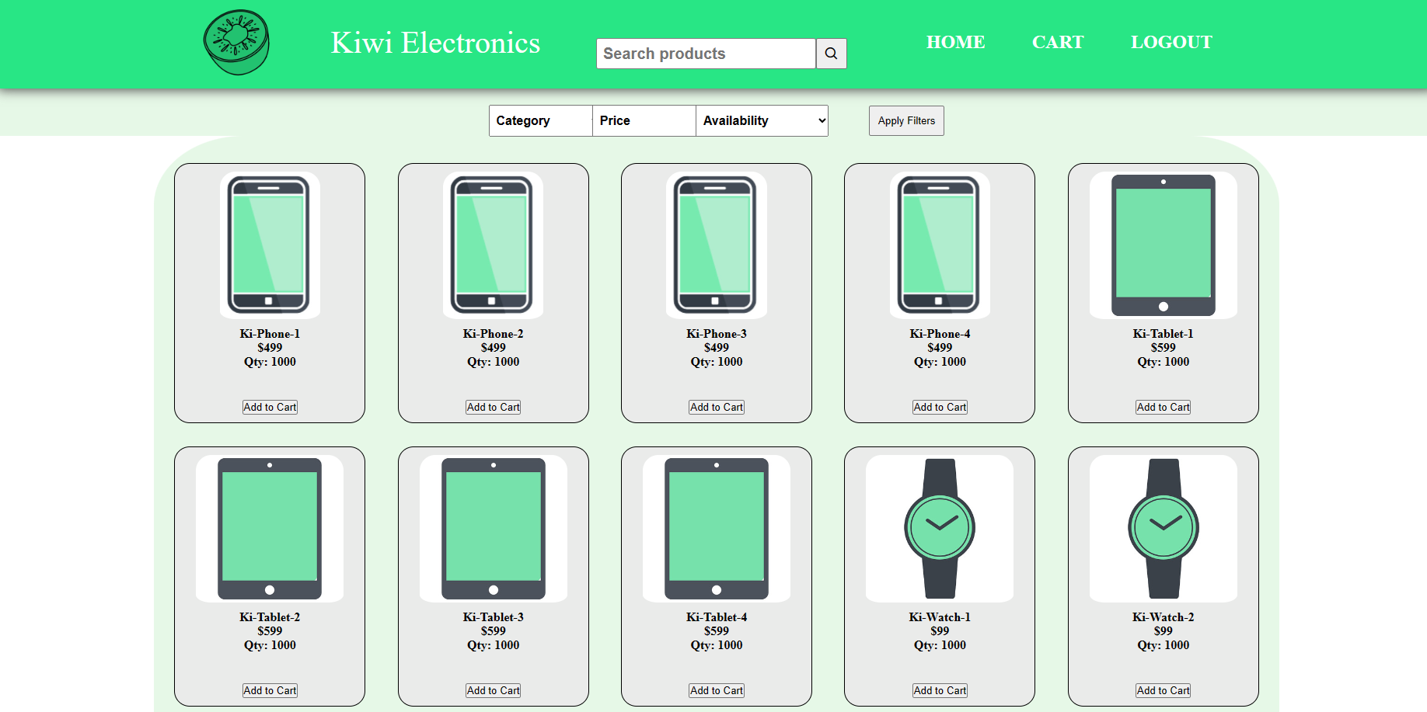

If the user is looking for something specific, they can use the search bar to look for a item.



Here is an example of “phone” being inputted into the search bar

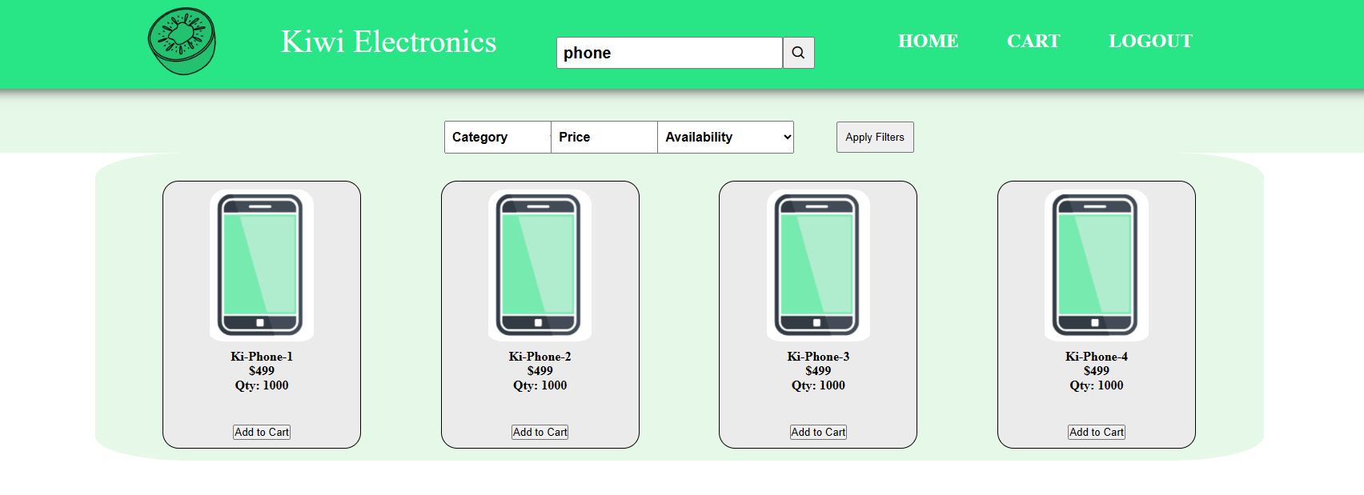

The user can also use the filters to look at specific products.

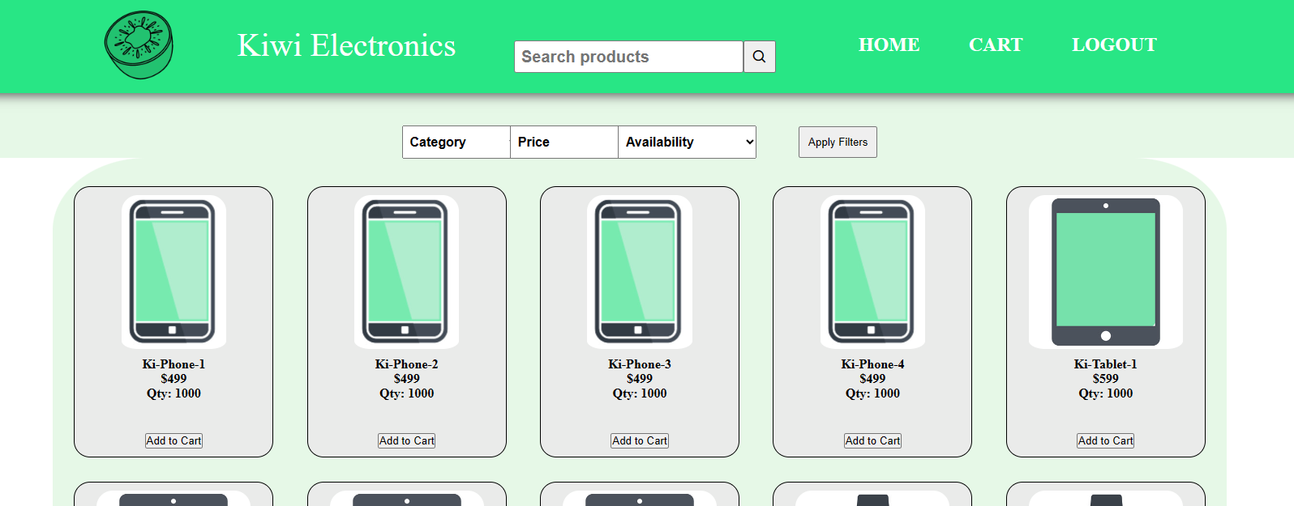

Here is an example of “Under 100” option being inputted into the filter “price”

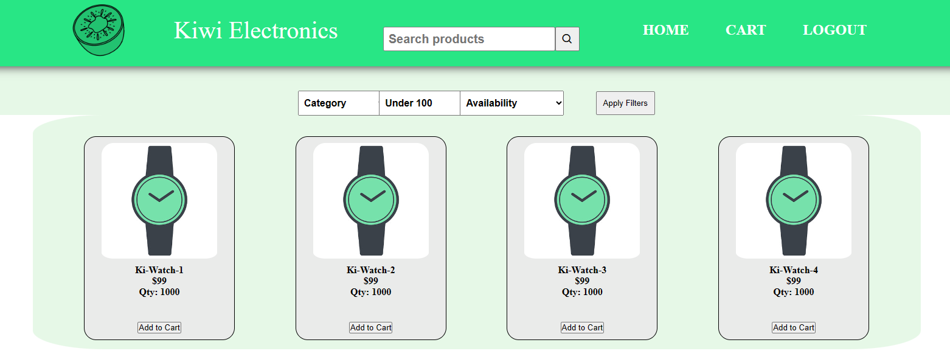

When the user has picked out a item that interests them, they can press the “add to cart” button to add that item to their cart.

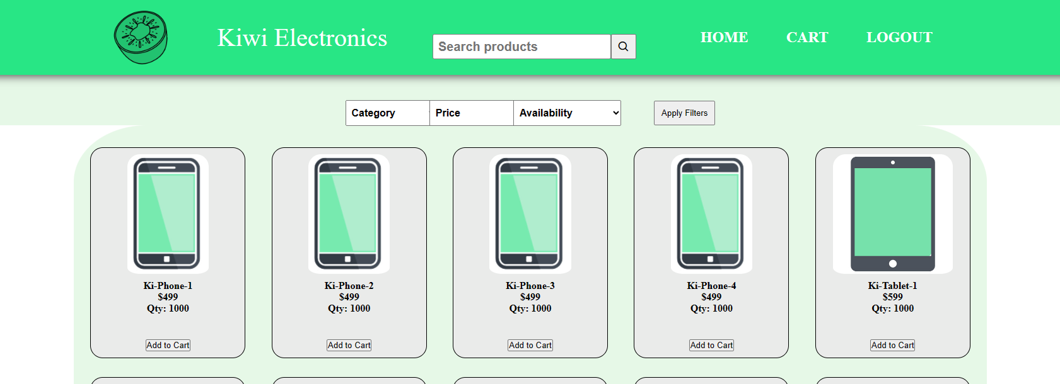

After pressing these add to cart buttons, they will press the cart to view their cart. 



**Cart Page:**

After entering cart, the user an see the three items the user selected from the products page. They can also see the total of these three items in the cart.

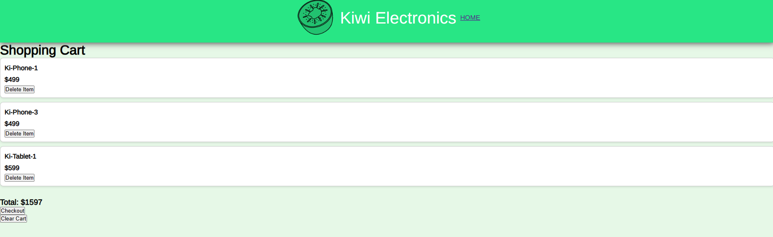

If the user decides that they want to remove an item from their cart, they can use the “delete item” button



This is an example of what the cart should look like after pressing the delete item button. If the user then wants to clear their entire cart, they can press the “clear cart” button.

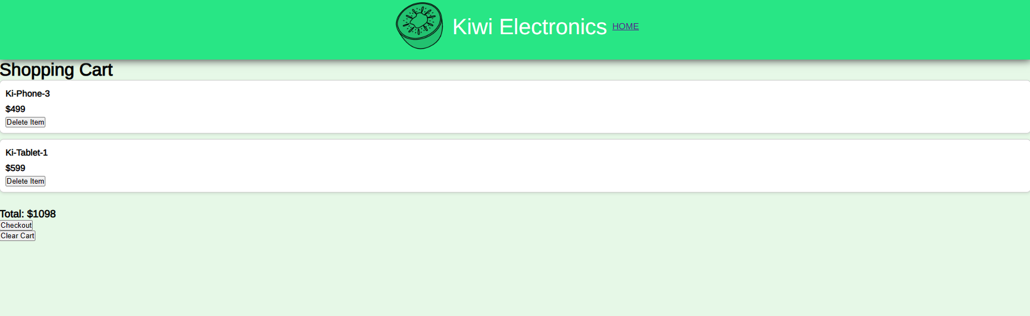

This is an example of what the cart should look like after pressing the clear cart button.

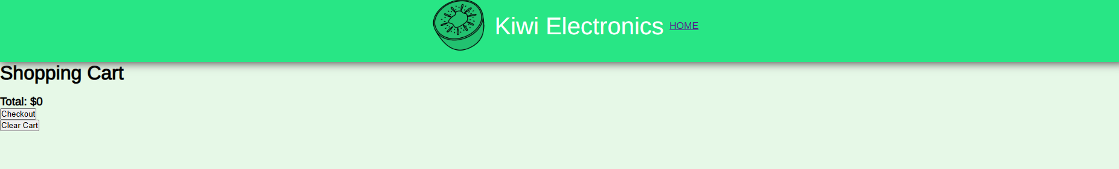

Going back to the three items selected, If the user decides they are satisfied and wants to begin their purchase, they will press the “checkout” button.



**Checkout Page:**

After redirected to the checkout page, the user’s information tied to their account will automatically appear in the checkout credentials. Here they can also view their subtotal and total of their cart.

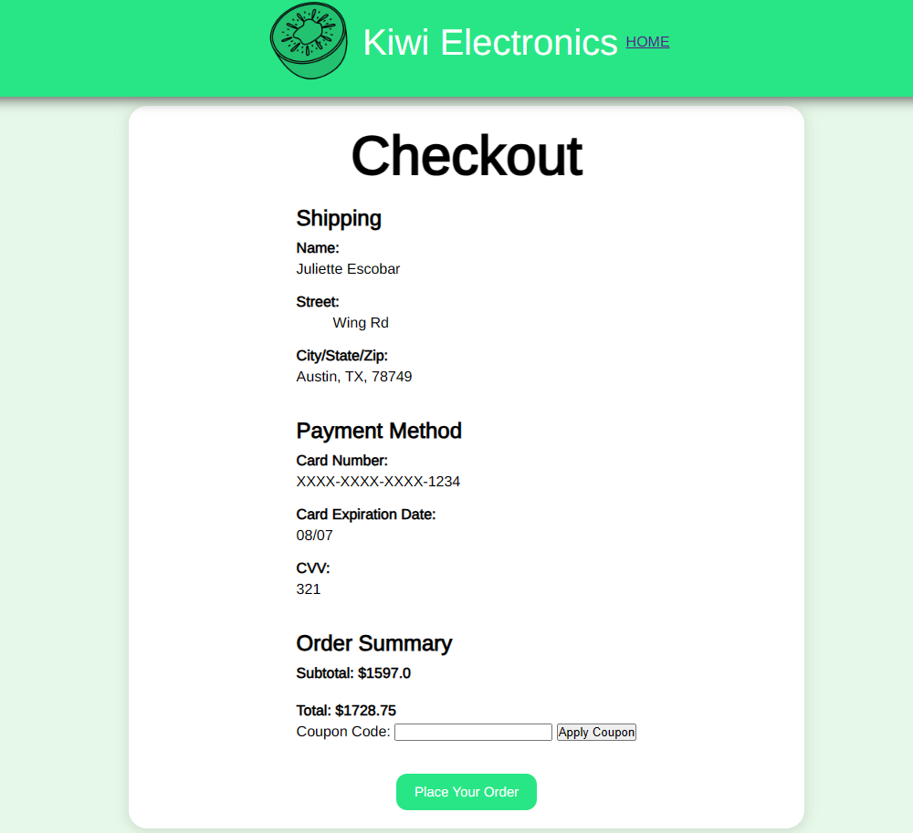

If the user has a coupon code, they can provide it in the coupon code area. 



Here is an example using our coupon code “CHRISTMAS” which takes 50 dollars off the total.

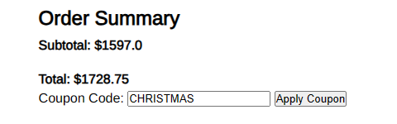

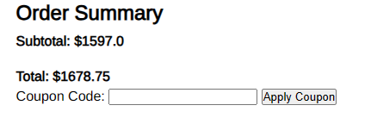

After the the user has applied their coupons and is satisfied with their checkout, they can press the “place your order” button. 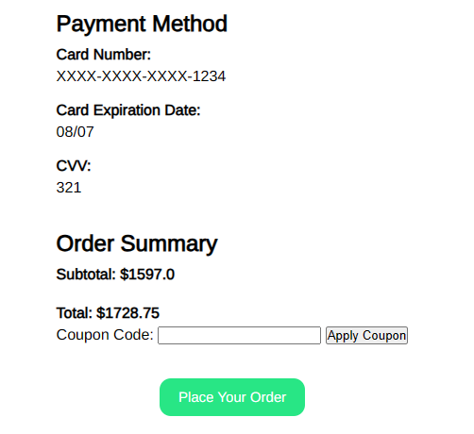



**Invoice Page:**

After placing their order, the user is provided with a invoice showing how much they paid and where it will be shipped to, along with their payment information.

From here, they can continue shopping and will be redirected to products page.

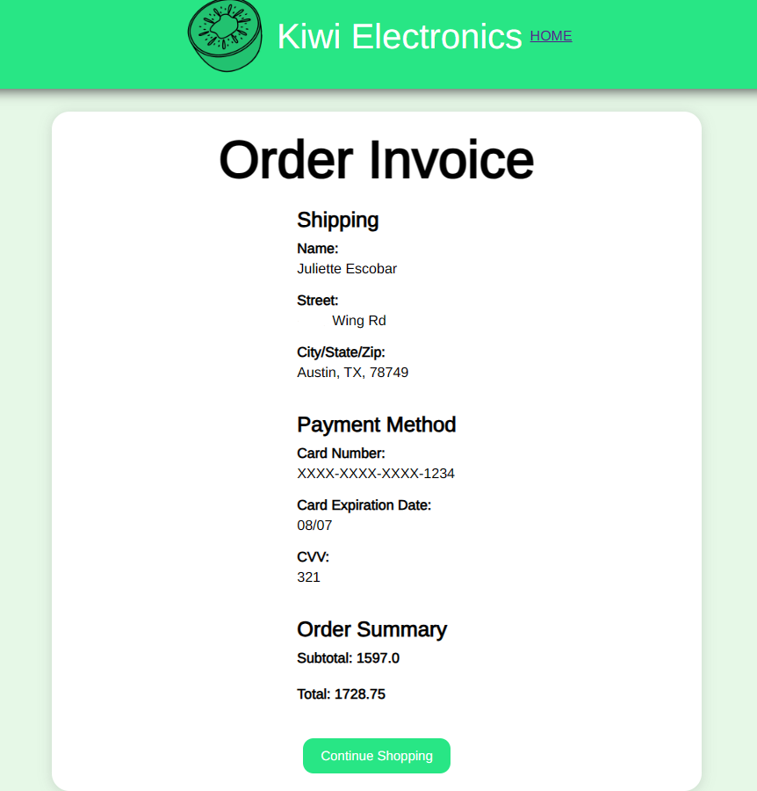

**Thank you for using our website!**

**UPDATED SPECIFICATIONS**

The purpose of our website is to provide users with a interactive and attractive ecommerce site to purchase electronics. We achieved this using Visual Studio Code, SQL, python and html languages. All of the information in our website is tied to the database we made in our SQL. By doing this, we are able to have all of our products stored dynamically on a separate server, and have every part of our website, including the cart, checkout, and invoice, interact with it. It is designed to behave according to the user’s input in real time. For example, as soon as a user clicks “add to cart” the database should add that item to the cart table so it can be shown in the cart.

This makes our website customer friendly for everyday people looking for electronics. From one of our user stories: Budgeting is one of my priorities, and as a consumer I would like the ability filter out the products that match my budget. By implementing filters in our website we save user’s time and money by giving them the option to look at the specific prices they can afford.

Going into some of the functions of our website, we included a few key features. First is the log in page, where a user is given a log in pop up to input all of their information that is thereafter stored in our database to create a unique session for each user. Another feature is our search bar and filters located in our shop. We used user input from both the search bar and filter to query through our database and pull specific products our customer is looking for. We set up our cart to be able to delete an item and clear entire cart while keeping track of the quantity of items, as well as calculate total at the bottom. From there, our checkout pulls all the information the user registered with from the database and uses it to display shipping and card information. There is a coupon code option that changes the total if it is a valid coupon found in the database. Our invoice is our last step were all of the information is displayed and the final total is shown, from there the user can continue shopping with a cleared cart.

Some of the limitations we ran into when making our website is lack of experience using html and python. Most of us had not used it before, so we had to learn somewhat from scratch. Most of us had also not used a database before, so we had to learn how to interact with it while creating our website. One of our strengths is we were very communicative in our group and helped each other a lot if anyone was struggling. This made it a lot easier to connect each part of our website, and make sure it was functioning how we wanted. To stay on track during development, we had semi-weekly meetings to keep each other updated on our progress. It took us about a month to develop, with most of the features being finely tuned the most the past week.